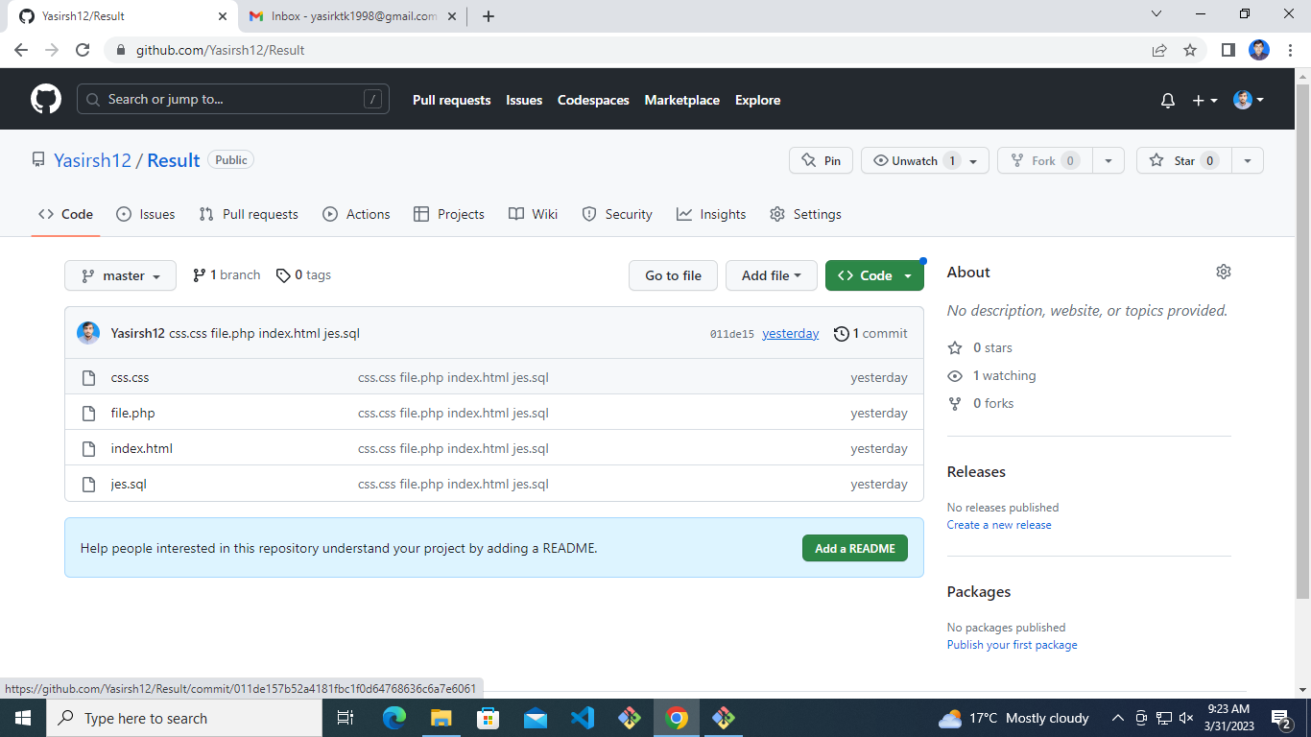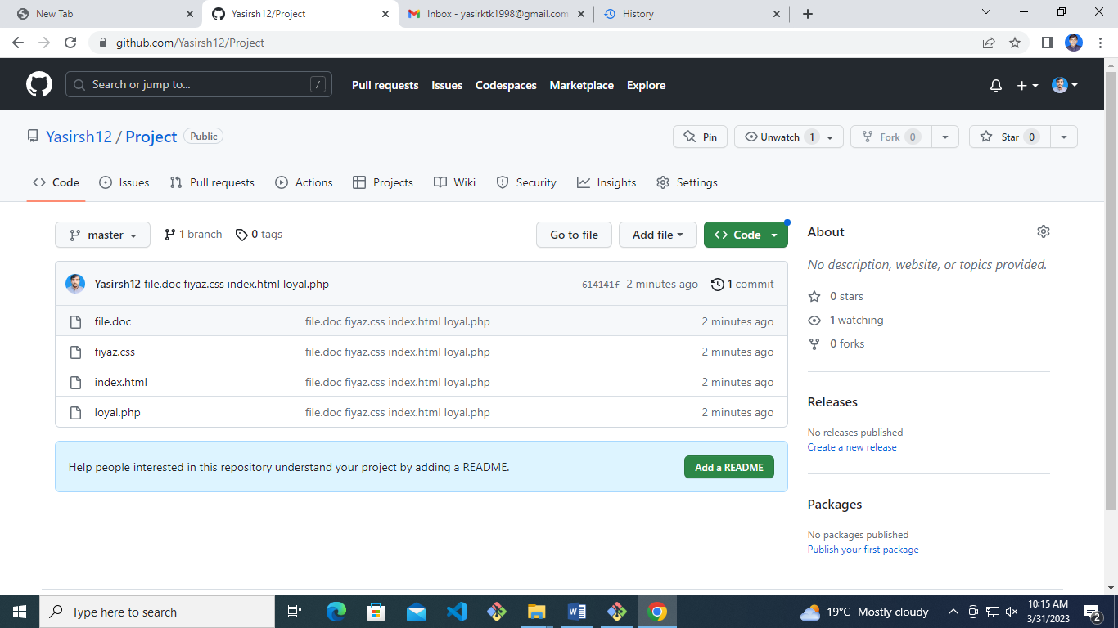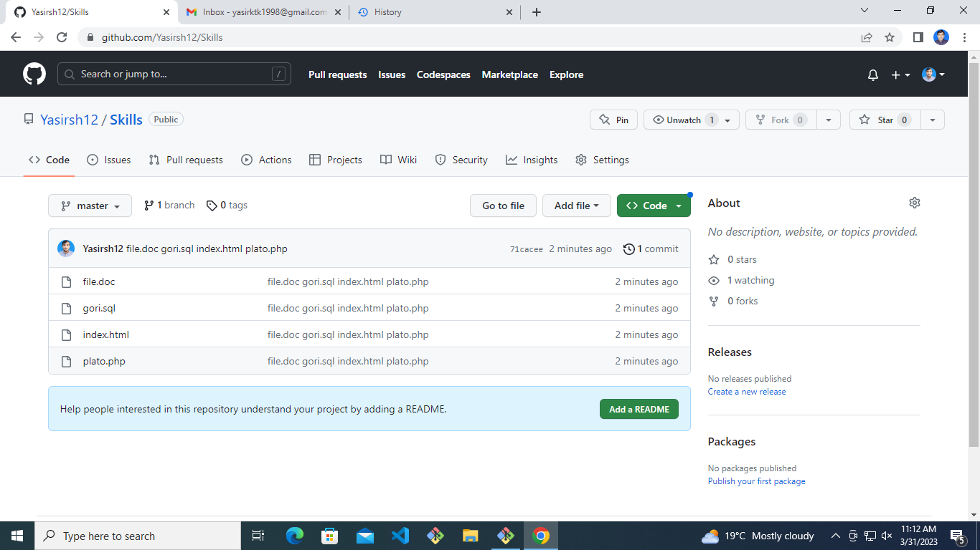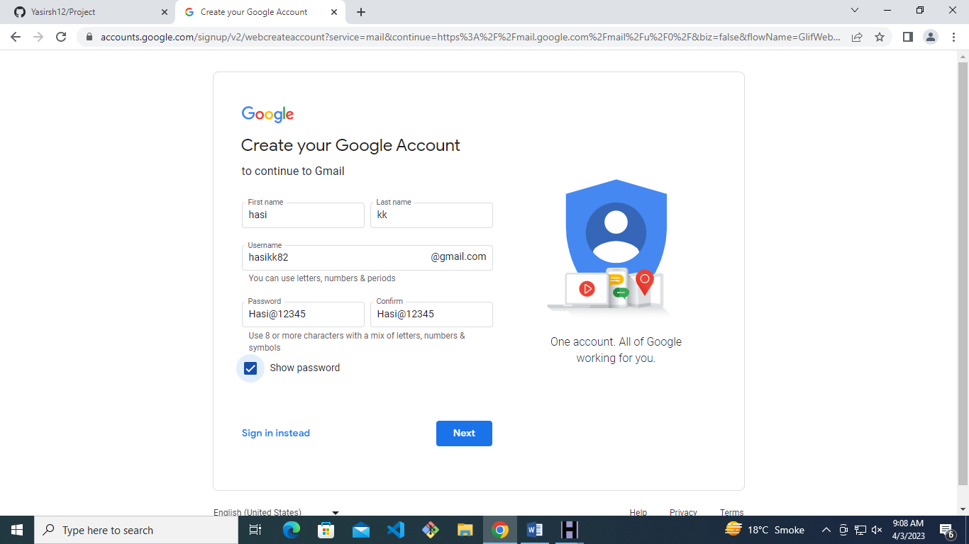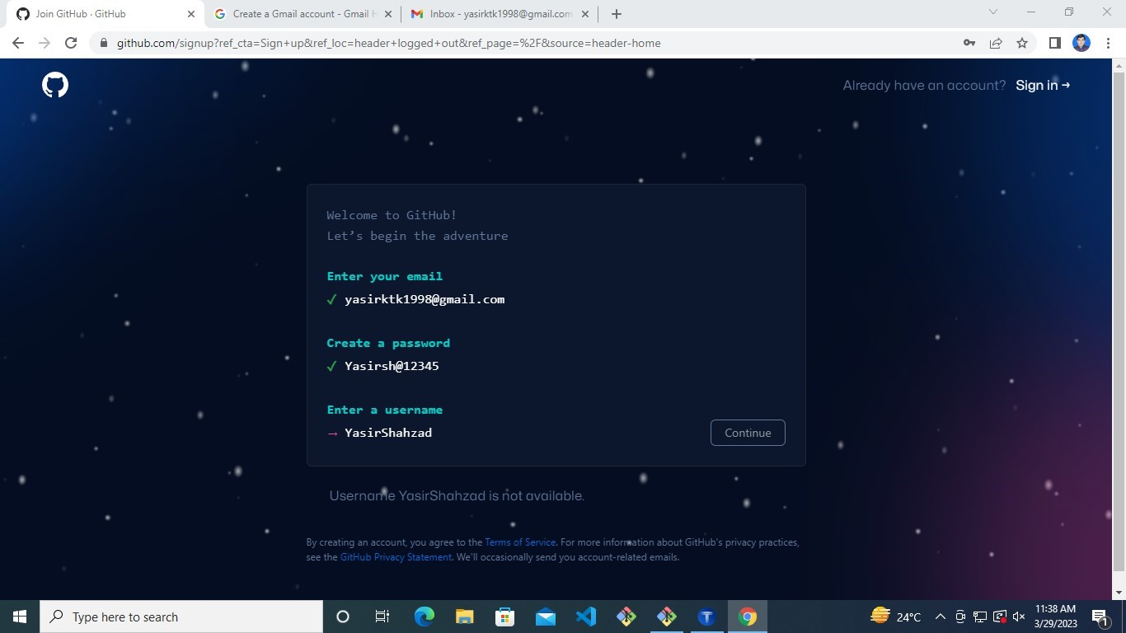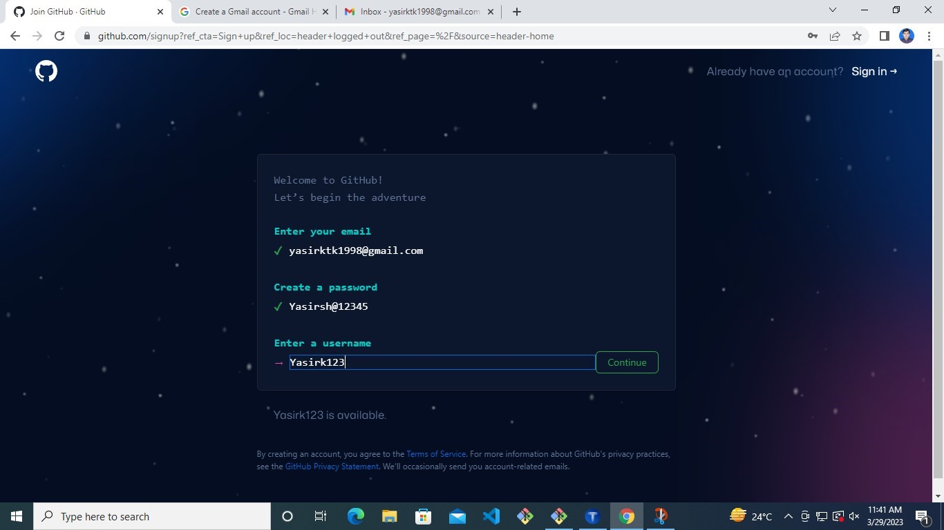

Administrator@DESKTOP-QT517IN MINGW64 ~/Documents/VisualCode

$ ls

Class1/ CloneProject/ User1/ project/ skills/ test1/

Administrator@DESKTOP-QT517IN MINGW64 ~/Documents/VisualCode

$ mkdir mussadiq

Administrator@DESKTOP-QT517IN MINGW64 ~/Documents/VisualCode

$ cd mussadiq/

Administrator@DESKTOP-QT517IN MINGW64 ~/Documents/VisualCode/mussadiq

$ touch file.doc index.html text.text

Administrator@DESKTOP-QT517IN MINGW64 ~/Documents/VisualCode/mussadiq

$ git init

Initialized empty Git repository in C:/Users/Administrator/Documents/VisualCode/mussadiq/.git/

Administrator@DESKTOP-QT517IN MINGW64 ~/Documents/VisualCode/mussadiq (master)

$ git status

On branch master

No commits yet

Untracked files:

(use "git add <file>..." to include in what will be committed)

file.doc

index.html

text.text

nothing added to commit but untracked files present (use "git add" to track)

Administrator@DESKTOP-QT517IN MINGW64 ~/Documents/VisualCode/mussadiq (master)

$ git add -A

Administrator@DESKTOP-QT517IN MINGW64 ~/Documents/VisualCode/mussadiq (master)

$ git status

On branch master

No commits yet

Changes to be committed:

(use "git rm --cached <file>..." to unstage)

new file: file.doc

new file: index.html

new file: text.text

Administrator@DESKTOP-QT517IN MINGW64 ~/Documents/VisualCode/mussadiq (master)

$ git commit -m "added file.doc index.html text.text"

[master (root-commit) 3bba8e1] added file.doc index.html text.text

3 files changed, 0 insertions(+), 0 deletions(-)

create mode 100644 file.doc

create mode 100644 index.html

create mode 100644 text.text

Administrator@DESKTOP-QT517IN MINGW64 ~/Documents/VisualCode/mussadiq (master)

$ git remote add origin https://github.com/Yasirsh12/mussadiq.git

Administrator@DESKTOP-QT517IN MINGW64 ~/Documents/VisualCode/mussadiq (master)

$ git push origin master

Enumerating objects: 3, done.

Counting objects: 100% (3/3), done.

Delta compression using up to 4 threads

Compressing objects: 100% (2/2), done.

Writing objects: 100% (3/3), 250 bytes | 250.00 KiB/s, done.

Total 3 (delta 0), reused 0 (delta 0), pack-reused 0

To https://github.com/Yasirsh12/mussadiq.git

* [new branch] master -> master

Administrator@DESKTOP-QT517IN MINGW64 ~/Documents/VisualCode/mussadiq (master)

$ git clone https://github.com/Yasirsh12/mussadiq.git

Cloning into 'mussadiq'...

remote: Enumerating objects: 3, done.

remote: Counting objects: 100% (3/3), done.

remote: Compressing objects: 100% (2/2), done.

remote: Total 3 (delta 0), reused 3 (delta 0), pack-reused 0

Receiving objects: 100% (3/3), done.

Administrator@DESKTOP-QT517IN MINGW64 ~/Documents/VisualCode/mussadiq (master)

$ ls

file.doc index.html mussadiq/ text.text

Administrator@DESKTOP-QT517IN MINGW64 ~/Documents/VisualCode/mussadiq (master)

$ touch gogli.sql

Administrator@DESKTOP-QT517IN MINGW64 ~/Documents/VisualCode/mussadiq (master)

$ git add -A

warning: adding embedded git repository: mussadiq

hint: You've added another git repository inside your current repository.

hint: Clones of the outer repository will not contain the contents of

hint: the embedded repository and will not know how to obtain it.

hint: If you meant to add a submodule, use:

hint:

hint: git submodule add <url> mussadiq

hint:

hint: If you added this path by mistake, you can remove it from the

hint: index with:

hint:

hint: git rm --cached mussadiq

hint:

hint: See "git help submodule" for more information.

g

Administrator@DESKTOP-QT517IN MINGW64 ~/Documents/VisualCode/mussadiq (master)

$ git commit -m "done"

[master 7e372df] done

2 files changed, 1 insertion(+)

create mode 100644 gogli.sql

create mode 160000 mussadiq

Administrator@DESKTOP-QT517IN MINGW64 ~/Documents/VisualCode/mussadiq (master)

$ git push master origin

error: src refspec origin does not match any

error: failed to push some refs to 'master'

Administrator@DESKTOP-QT517IN MINGW64 ~/Documents/VisualCode/mussadiq (master)

$ git push origin master

Enumerating objects: 3, done.

Counting objects: 100% (3/3), done.

Delta compression using up to 4 threads

Compressing objects: 100% (2/2), done.

Writing objects: 100% (2/2), 300 bytes | 300.00 KiB/s, done.

Total 2 (delta 0), reused 0 (delta 0), pack-reused 0

To https://github.com/Yasirsh12/mussadiq.git

3bba8e1..7e372df master -> master

c

Administrator@DESKTOP-QT517IN MINGW64 ~/Documents/VisualCode/mussadiq (master)

$ cd mussadiq/

Administrator@DESKTOP-QT517IN MINGW64 ~/Documents/VisualCode/mussadiq/mussadiq (master)

$ git push origin master

To https://github.com/Yasirsh12/mussadiq.git

! [rejected] master -> master (fetch first)

error: failed to push some refs to 'https://github.com/Yasirsh12/mussadiq.git'

hint: Updates were rejected because the remote contains work that you do

hint: not have locally. This is usually caused by another repository pushing

hint: to the same ref. You may want to first integrate the remote changes

hint: (e.g., 'git pull ...') before pushing again.

hint: See the 'Note about fast-forwards' in 'git push --help' for details.

Administrator@DESKTOP-QT517IN MINGW64 ~/Documents/VisualCode/mussadiq/mussadiq (master)

$ git branch

* master

Administrator@DESKTOP-QT517IN MINGW64 ~/Documents/VisualCode/mussadiq/mussadiq (master)

$ git branch obaid

Administrator@DESKTOP-QT517IN MINGW64 ~/Documents/VisualCode/mussadiq/mussadiq (master)

$ git branch

* master

obaid

Administrator@DESKTOP-QT517IN MINGW64 ~/Documents/VisualCode/mussadiq/mussadiq (master)

$ git checkout obaid

Switched to branch 'obaid'

Administrator@DESKTOP-QT517IN MINGW64 ~/Documents/VisualCode/mussadiq/mussadiq (obaid)

$ git branch

master

* obaid

Administrator@DESKTOP-QT517IN MINGW64 ~/Documents/VisualCode/mussadiq/mussadiq (obaid)

$ git push origin obaid

Enumerating objects: 3, done.

Counting objects: 100% (3/3), done.

Delta compression using up to 4 threads

Compressing objects: 100% (2/2), done.

Writing objects: 100% (3/3), 250 bytes | 250.00 KiB/s, done.

Total 3 (delta 0), reused 3 (delta 0), pack-reused 0

remote:

remote: Create a pull request for 'obaid' on GitHub by visiting:

remote: https://github.com/Yasirsh12/mussadiq/pull/new/obaid

remote:

To https://github.com/Yasirsh12/mussadiq.git

* [new branch] obaid -> obaid

Administrator@DESKTOP-QT517IN MINGW64 ~/Documents/VisualCode/mussadiq/mussadiq (obaid)

$ git checkout master

Switched to branch 'master'

Your branch is up to date with 'origin/master'.

Administrator@DESKTOP-QT517IN MINGW64 ~/Documents/VisualCode/mussadiq/mussadiq (master)

$ git branch

* master

obaid

Administrator@DESKTOP-QT517IN MINGW64 ~/Documents/VisualCode/mussadiq/mussadiq (master)

$ git status

On branch master

Your branch is up to date with 'origin/master'.

nothing to commit, working tree clean

Administrator@DESKTOP-QT517IN MINGW64 ~/Documents/VisualCode/mussadiq/mussadiq (master)

$ ls

file.doc index.html text.text

Administrator@DESKTOP-QT517IN MINGW64 ~/Documents/VisualCode/mussadiq/mussadiq (master)

$ git pull origin master

remote: Enumerating objects: 3, done.

remote: Counting objects: 100% (3/3), done.

remote: Compressing objects: 100% (2/2), done.

remote: Total 2 (delta 0), reused 2 (delta 0), pack-reused 0

Unpacking objects: 100% (2/2), 280 bytes | 56.00 KiB/s, done.

From https://github.com/Yasirsh12/mussadiq

* branch master -> FETCH_HEAD

3bba8e1..7e372df master -> origin/master

Updating 3bba8e1..7e372df

Fast-forward

gogli.sql | 0

mussadiq | 1 +

2 files changed, 1 insertion(+)

create mode 100644 gogli.sql

create mode 160000 mussadiq

Administrator@DESKTOP-QT517IN MINGW64 ~/Documents/VisualCode/mussadiq/mussadiq (master)

$ git config --global --list

gui.recentrepo=C:/Users/Administrator/Documents/VisualCode/Class1

user.email=yasirktk1998@gmail.com

user.name=Yasirsh12

Administrator@DESKTOP-QT517IN MINGW64 ~/Documents/VisualCode/mussadiq/mussadiq (master)

$ git log

commit 7e372df82747daf43e9a54a413110eaeb044f8ca (HEAD -> master, origin/master, origin/HEAD)

Author: Yasirsh12 <yasirktk1998@gmail.com>

Date: Tue Apr 4 14:34:51 2023 -0700

done

commit 3bba8e157e352f196a4fa9d93292d3a6b5615983 (origin/obaid, obaid)

Author: Yasirsh12 <yasirktk1998@gmail.com>

Date: Tue Apr 4 14:19:06 2023 -0700

added file.doc index.html text.text

Administrator@DESKTOP-QT517IN MINGW64 ~/Documents/VisualCode/mussadiq/mussadiq (master)

$ git log -2

commit 7e372df82747daf43e9a54a413110eaeb044f8ca (HEAD -> master, origin/master, origin/HEAD)

Author: Yasirsh12 <yasirktk1998@gmail.com>

Date: Tue Apr 4 14:34:51 2023 -0700

done

commit 3bba8e157e352f196a4fa9d93292d3a6b5615983 (origin/obaid, obaid)

Author: Yasirsh12 <yasirktk1998@gmail.com>

Date: Tue Apr 4 14:19:06 2023 -0700

added file.doc index.html text.text

Administrator@DESKTOP-QT517IN MINGW64 ~/Documents/VisualCode/mussadiq/mussadiq (master)

$ git log oneline

fatal: ambiguous argument 'oneline': unknown revision or path not in the working tree.

Use '--' to separate paths from revisions, like this:

'git <command> [<revision>...] -- [<file>...]'

Administrator@DESKTOP-QT517IN MINGW64 ~/Documents/VisualCode/mussadiq/mussadiq (master)

$ git log --oneline

7e372df (HEAD -> master, origin/master, origin/HEAD) done

3bba8e1 (origin/obaid, obaid) added file.doc index.html text.text

Administrator@DESKTOP-QT517IN MINGW64 ~/Documents/VisualCode/mussadiq/mussadiq (master)

$ git log --grep = "index.html"

Administrator@DESKTOP-QT517IN MINGW64 ~/Documents/VisualCode/mussadiq/mussadiq (master)

$ git status

On branch master

Your branch is up to date with 'origin/master'.

nothing to commit, working tree clean

Administrator@DESKTOP-QT517IN MINGW64 ~/Documents/VisualCode/mussadiq/mussadiq (master)

$

**Cherry cmd**

Administrator@DESKTOP-QT517IN MINGW64 ~

$ ls

'3D Objects'/ Music/ Pictures/

AppData/ 'My Documents'@ PrintHood@

'Application Data'@ NTUSER.DAT Recent@

Contacts/ NTUSER.DAT{53b39e87-18c4-11ea-a811-000d3aa4692b}.TxR.0.regtrans-ms 'Saved Games'/

Cookies@ NTUSER.DAT{53b39e87-18c4-11ea-a811-000d3aa4692b}.TxR.1.regtrans-ms Searches/

Desktop/ NTUSER.DAT{53b39e87-18c4-11ea-a811-000d3aa4692b}.TxR.2.regtrans-ms SendTo@

Documents/ NTUSER.DAT{53b39e87-18c4-11ea-a811-000d3aa4692b}.TxR.blf 'Start Menu'@

Downloads/ NTUSER.DAT{53b39e88-18c4-11ea-a811-000d3aa4692b}.TM.blf Templates@

Favorites/ NTUSER.DAT{53b39e88-18c4-11ea-a811-000d3aa4692b}.TMContainer00000000000000000001.regtrans-ms Videos/

IntelGraphicsProfiles/ NTUSER.DAT{53b39e88-18c4-11ea-a811-000d3aa4692b}.TMContainer00000000000000000002.regtrans-ms ntuser.dat.LOG1

Links/ NetHood@ ntuser.dat.LOG2

'Local Settings'@ OneDrive/ ntuser.ini

Administrator@DESKTOP-QT517IN MINGW64 ~

$ cd Documents/VisualCode/

Administrator@DESKTOP-QT517IN MINGW64 ~/Documents/VisualCode

$ ls

Class1/ CloneProject/ User1/ mussadiq/ project/ skills/ test1/ user2/ user3/

Administrator@DESKTOP-QT517IN MINGW64 ~/Documents/VisualCode

$ cd CloneProject/

Administrator@DESKTOP-QT517IN MINGW64 ~/Documents/VisualCode/CloneProject (master)

$ ls

file.doc file.php hy.txt index.txt stash.html

Administrator@DESKTOP-QT517IN MINGW64 ~/Documents/VisualCode/CloneProject (master)

$ git branch yasir

Administrator@DESKTOP-QT517IN MINGW64 ~/Documents/VisualCode/CloneProject (master)

$ git branch

* master

test

yasir

Administrator@DESKTOP-QT517IN MINGW64 ~/Documents/VisualCode/CloneProject (master)

$ git checkout yasir

Switched to branch 'yasir'

Administrator@DESKTOP-QT517IN MINGW64 ~/Documents/VisualCode/CloneProject (yasir)

$ git branch

master

test

* yasir

Administrator@DESKTOP-QT517IN MINGW64 ~/Documents/VisualCode/CloneProject (yasir)

$ touch hy.doc

Administrator@DESKTOP-QT517IN MINGW64 ~/Documents/VisualCode/CloneProject (yasir)

$ git add hy.doc

Administrator@DESKTOP-QT517IN MINGW64 ~/Documents/VisualCode/CloneProject (yasir)

$ git commit -m "hy.doc"

[yasir 048cc4e] hy.doc

1 file changed, 0 insertions(+), 0 deletions(-)

create mode 100644 hy.doc

Administrator@DESKTOP-QT517IN MINGW64 ~/Documents/VisualCode/CloneProject (yasir)

$ git log

commit 048cc4eca2ed27612952a0e7a20fab44b39b7fe2 (HEAD -> yasir)

Author: Yasirsh12 <yasirktk1998@gmail.com>

Date: Fri Apr 7 09:07:36 2023 -0700

hy.doc

commit 3afbc9e2f1c94f17bbc4412ed0f8b6628e79e03b (master)

Author: Yasirsh12 <yasirktk1998@gmail.com>

Date: Thu Apr 6 12:00:45 2023 -0700

hy.txt

commit c5aa0692ab46a24d943161a2dc54f022105b8945 (origin/master)

Author: Yasirsh12 <yasirktk1998@gmail.com>

Date: Tue Apr 4 12:06:37 2023 -0700

done

commit fdaeb8f801140b775c31b91681833c631259687a

Author: Yasirsh12 <yasirktk1998@gmail.com>

Date: Tue Apr 4 12:02:05 2023 -0700

added file.doc index.txt

Administrator@DESKTOP-QT517IN MINGW64 ~/Documents/VisualCode/CloneProject (yasir)

$ ^C

Administrator@DESKTOP-QT517IN MINGW64 ~/Documents/VisualCode/CloneProject (yasir)

$ git checkout master

Switched to branch 'master'

Administrator@DESKTOP-QT517IN MINGW64 ~/Documents/VisualCode/CloneProject (master)

$ git cherry-pick 048cc4eca2ed27612952a0e7a20fab44b39b7fe2

[master 00233d1] hy.doc

Date: Fri Apr 7 09:07:36 2023 -0700

1 file changed, 0 insertions(+), 0 deletions(-)

create mode 100644 hy.doc

Administrator@DESKTOP-QT517IN MINGW64 ~/Documents/VisualCode/CloneProject (master)

$ lis

bash: lis: command not found

Administrator@DESKTOP-QT517IN MINGW64 ~/Documents/VisualCode/CloneProject (master)

$ ls

file.doc file.php hy.doc hy.txt index.txt stash.html

Administrator@DESKTOP-QT517IN MINGW64 ~/Documents/VisualCode/CloneProject (master)

$